Day 3-ish
Exercise 1: Word stress in Pintupi
Pintupi is an Australian Aboriginal language. It is one of the Wati languages of the large Pama–Nyungan family. It is one of the varieties of the Western Desert Language (WDL). In 2016, the language had 147 native speakers.

Spoken Pintupi: https://www.youtube.com/watch?v=ui5bbjeVjD8

Consider the stress patterns below:

[ˈt^{j}aː] ‘mouth’ [ˈka.pa.li] ‘mother’s mother’
[ˈmu.ŋu] ‘orphan’ [ˈŋal.ku.ˌnin.pa] ‘eating’
[ˈmuː.ŋu] ‘fly’ [ˈpu.ɭiŋ.ˌka.la.t^{j}u] ‘we (sat) on the hill’
[ˈt^{j}an.pa] ‘evil spirit’ [ˈt^{j}a.mu.ˌlim.pa.ˌt^{j}uŋ.ku] ‘our relation’

What generalizations about the distribution of stress can you observe in these data?

Exercise 2: Word stress in Latin
Latin is a classical language belonging to the Italic branch of the Indo-European languages. Latin was originally a dialect spoken in the lower Tiber area around present-day Rome (then known as Latium),[2] and through the power of the Roman Republic, became the dominant language in Italia and subsequently throughout the realms of Roman Empire.

Primary word stress in Latin is either on the penultimate (2nd from the right) or on the antepenultimate syllable (3rd from the right) – accent marks denote stress:

a.mí:.cus ‘friend’
vó.lu.cres ‘bird (pl.)’
sí.mu.la: ‘pretender’
re.fé:.cit ‘rebuild (3sg. perf.)’
a.grí.co.la ‘farmer’
pe.pér.ci ‘save (1sg. perf.)’
ma.gís.ter ‘master’

What generalizations about the distribution of stress can you observe in these data?

Exercise 3: Word stress in Pintupi (again)
Consider the stress patterns below:

[ˈt^{j}aː] ‘mouth’ [ˈka.pa.li] ‘mother’s mother’
[ˈmu.ŋu] ‘orphan’ [ˈŋal.ku.ˌnin.pa] ‘eating’
[ˈmuː.ŋu] ‘fly’ [ˈpu.ɭiŋ.ˌka.la.t^{j}u] ‘we (sat) on the hill’
[ˈt^{j}an.pa] ‘evil spirit’ [ˈt^{j}a.mu.ˌlim.pa.ˌt^{j}uŋ.ku] ‘our relation’

- Is the language left-dominant or right-dominant?
- Is the language quantity-sensitive? Provide arguments.
- Does the language allow degenerate feet?
- Draw brackets around the feet.

Exercise 4: Word stress in Araucanian
The Araucanian languages are a language family of indigenous languages of the Americas spoken in central Chile and neighboring areas of Argentina. The living representatives of this family are Mapudungun and Huilliche, spoken respectively by the Mapuche and Huilliche people. These are sometimes considered divergent dialects of a single language isolate. It is estimated that there are approximately 200,000 Mapudungun speakers in Chile and 40,000 speakers in Argentina. Huilliche is the native language of a few thousand Chileans.

Spoken Mapudungun: https://www.youtube.com/watch?v=DcPu6zLpZoQ

Consider the stress patterns below – accent marks denote stress:

wu.lé ‘tomorrow’
tu.pán.to ‘year’
e.lá.a.è.new ‘he will give me’
ki.mú.fa.lù.wu.làj ‘he pretended not to know’

- Is the language left-dominant or right-dominant? Give arguments.
- Is the language quantity-sensitive? Give arguments.
- Is footing from left to right or from right to left? Give arguments.
- Does the language allow degenerate feet?

Exercise 5: Word stress in Latin (again)
Primary word stress in Latin is either on the penultimate (2nd from the right) or on the antepenultimate syllable (3rd from the right) – accent marks denote stress:

a.mí:.cus ‘friend’
vó.lu.cres ‘bird (pl.)’
sí.mu.la: ‘pretender’
re.fé:.cit ‘rebuild (3sg. perf.)’
a.grí.co.la ‘farmer’
pe.pér.ci ‘save (1sg. perf.)’
ma.gís.ter ‘master’

Answer the following questions on the basis of the provided facts:
- Is the language left-dominant or right-dominant?
- Is the language quantity-sensitive? Do closed syllables count as heavy? Provide arguments.
- Does the language have extrametricality? If so, what is extrametrical?

Day 4-ish
Exercise 1: Stress in Hungarian
Consider the stress patterns below (accent marks denote stress):
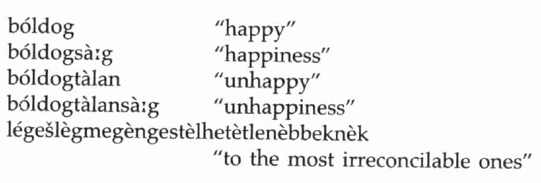

- Is Hungarian left-dominant or right-dominant?
- Is footing from left to right or from right to left?
- Is there evidence that Hungarian stress is quantity-sensitive?
- Is there evidence for extrametricality in Hungarian?
- Does Hungarian allow degenerate feet?
- What similarities and differences can you identify between the stress patterns of Hungarian and Pintupi (see again below)?

[ˈt^{j}aː] ‘mouth’ [ˈka.pa.li] ‘mother’s mother’
[ˈmu.ŋu] ‘orphan’ [ˈŋal.ku.ˌnin.pa] ‘eating’
[ˈmuː.ŋu] ‘fly’ [ˈpu.ɭiŋ.ˌka.la.t^{j}u] ‘we (sat) on the hill’
[ˈt^{j}an.pa] ‘evil spirit’ [ˈt^{j}a.mu.ˌlim.pa.ˌt^{j}uŋ.ku] ‘our relation’

Exercise 2: Stress in Warao
Consider the stress patterns below. Adjacent vowels are never diphthongs, that is, sequences like, e.g., [ai] or [au] count as two syllables.

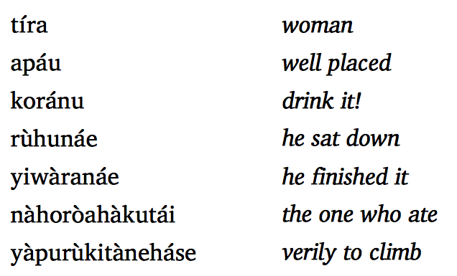

- Are feet in Warao left-dominant or right-dominant?
- Is footing from left to right or from right to left?
- Is there evidence that Warao stress is quantity-sensitive?
- Is there evidence for extrametricality in Warao?
- Does Warao allow degenerate feet?
- What are similarities and differences between Warao and Hungarian / Pintupi?

Examples 3: Hawaiian
Observe the stress patterns in Hawaiian – accent marks denote stress.
a.ká:.ka ‘clear’ ne.nè.le.áu ‘sumac’
há.le ‘house’ hò.ʔo.làu.lé.ʔa ‘celebration’
ha.náu.ma a place name kò:.ʔè.le.ʔé.le species of seaweed
ka.ná.ka ‘person’ kù:.nà:.ná: ‘puzzled’
ma.lá.ma ‘light’ mà:.là.ma.lá.ma ‘clear’
ʔe.kà.le.sí.a ‘church’ hu.è.le.é.lo ‘having tails’
hà.na.léi a place name ka.mè.ha.mé.ha a name
hèi.áu ‘ancient temple’ ka.pì.ʔo.lá.ni a name
kà:.ná.ka ‘people’ ka.là:.káu.a a name
mà:.lá.ma ‘to care for’ ka.ì.mu.kí: a place name

- Is Hawaiian left-dominant or right-dominant?
- Is footing from left to right or from right to left?
- Is there evidence that Hawaiian stress is quantity-sensitive?
- Is there evidence for extrametricality in Hawaiian?
- Does Hawaiian allow degenerate feet?

Example 4: More stress in Latin
Recall the analysis of Latin stress. Determine on the basis of what we have discussed before where stress would fall in the following words, and why.
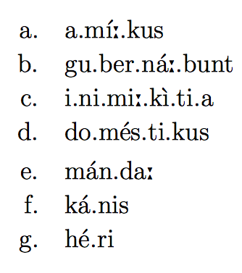
Exercise 5: Lithuanian
Investigate the phenomenon of nasal loss in Lithuanian below.

sprɛn-dʒa ‘decides’ spræ:-stɪ ‘to decide’
sʊn-tʃɛ ‘sends’ su:-stɪ ‘to send’

- Capture the phenomenon of nasal loss with a feature-based rule. Do we need to reference syllable structure for this rule?
- What does the lengthening of the first syllable nucleus after nasal loss suggest about Lithuanian syllable structure? What principle is this lengthening an instance of?
- What generalization can you make about long vowels in Lithuanian?
Exercise 6: Stress in Malaccan Portuguese Creole
Consider the stress patterns below:
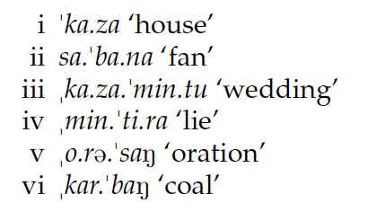

- Is the language iambic or trochaic? Give arguments.
- Is the language quantity-sensitive? Give arguments.
- Is footing from left to right or from right to left? Give arguments.
- Is there evidence for extrametricality? Give arguments.
- Does the language allow degenerate feet? Give arguments.

Exercise 7: Stress in Cahuilla
Consider the stress patterns in Cahuilla. Note that in this language, glottal stops are the only moraic consonants; furthermore, [w] and [j] are the second parts of diphthongs and count as moraic.

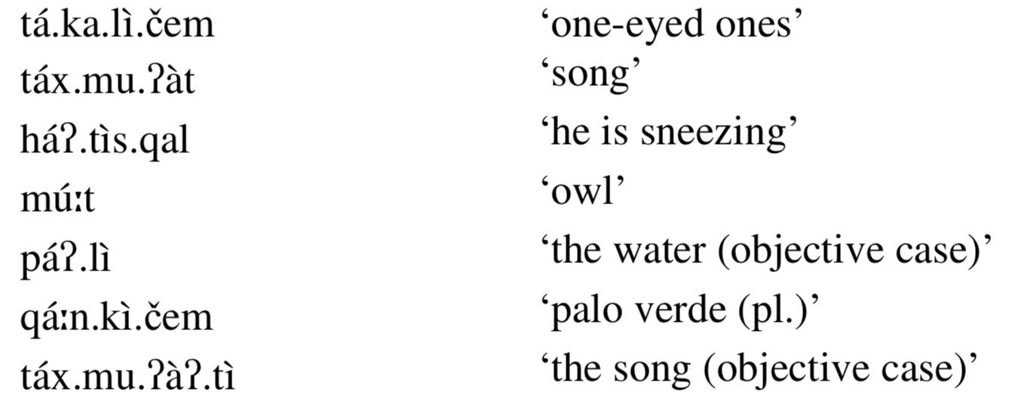
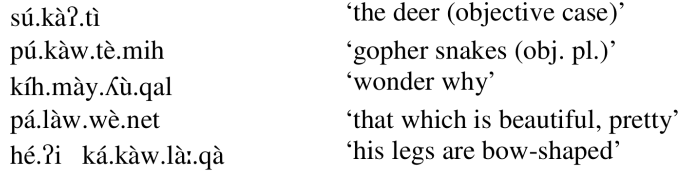
- Is Cahuilla left-dominant or right-dominant?
- Is footing from left to right or from right to left?
- Is there evidence that Cahuilla stress is quantity-sensitive?
- Is there evidence for extrametricality in Cahuilla?
- Does Cahuilla allow degenerate feet?

Exercise 8: Stress in Creek
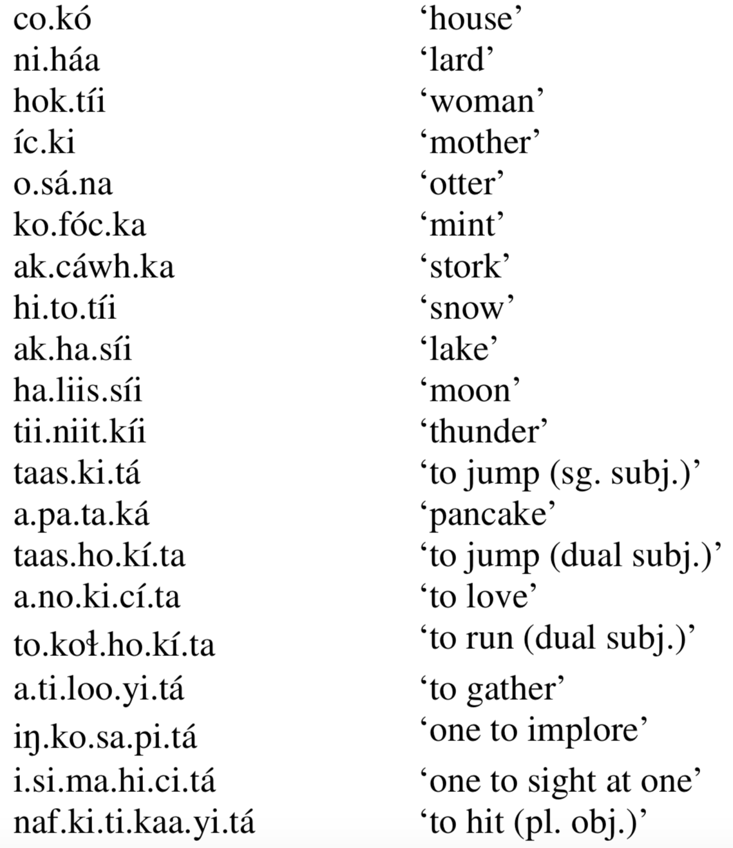

Note that only primary stress is audible in this language, so you will have to derive the other feet in a way that they correctly predict the location of primary stress. Hint: The fact that stress cannot be entirely predicted based on syllable number is a reliable indicator of what?

- Can you tell whether coda consonants are moraic?
- Is Creek right-dominant or left-dominant?
- Is footing from left to right or from right to left?
- Is there evidence that Creek stress is quantity-sensitive?
- Is there evidence for extrametricality in Creek?
- Does Creek allow degenerate feet?

